2025 Bradley Beach Shade Tree Commission
Annual Accomplishments Report

Executive Summary: The Bradley Beach Shade Tree Commission had a productive and fruitful year.

Applications:
The STC received and reviewed 27 Tree Removal Permit applications in 2025.
- 5 trees were removed from planting strips, and 34 trees were removed from private property, for a total of 39 trees removed.
- 52 trees are slated to replace the trees approved for removal.
- One assessment was paid in lieu of tree replacement.

The STC received 6 Honor Me Tree Applications.

The STC received 35 Wishing Tree Applications.

New and Continuing Projects:
- Pollinator Point, in the median of 2nd Ave and Beach, continues to grow and develop with new native woody shrubs to attract more pollinators.
The adjoining median, in which we planted 4 blueberry bushes in 2024, was expanded with 16 more blueberry bushes of 3 different cultivars.

- Tree of the Month continued to be published in local newspapers and the Mayor’s Newsletter with a new author. The focus is expanding to include responsible tree care, information about STC programs available for residents, and the importance of our tree canopy.
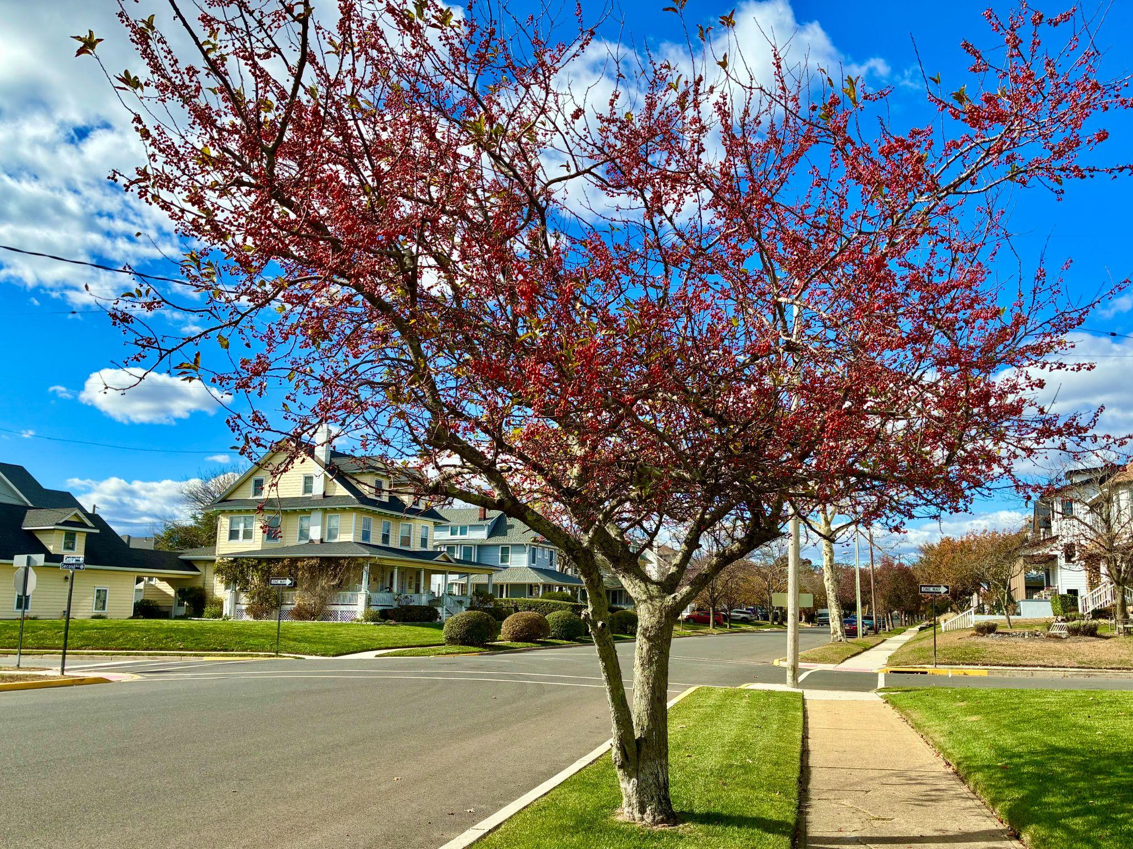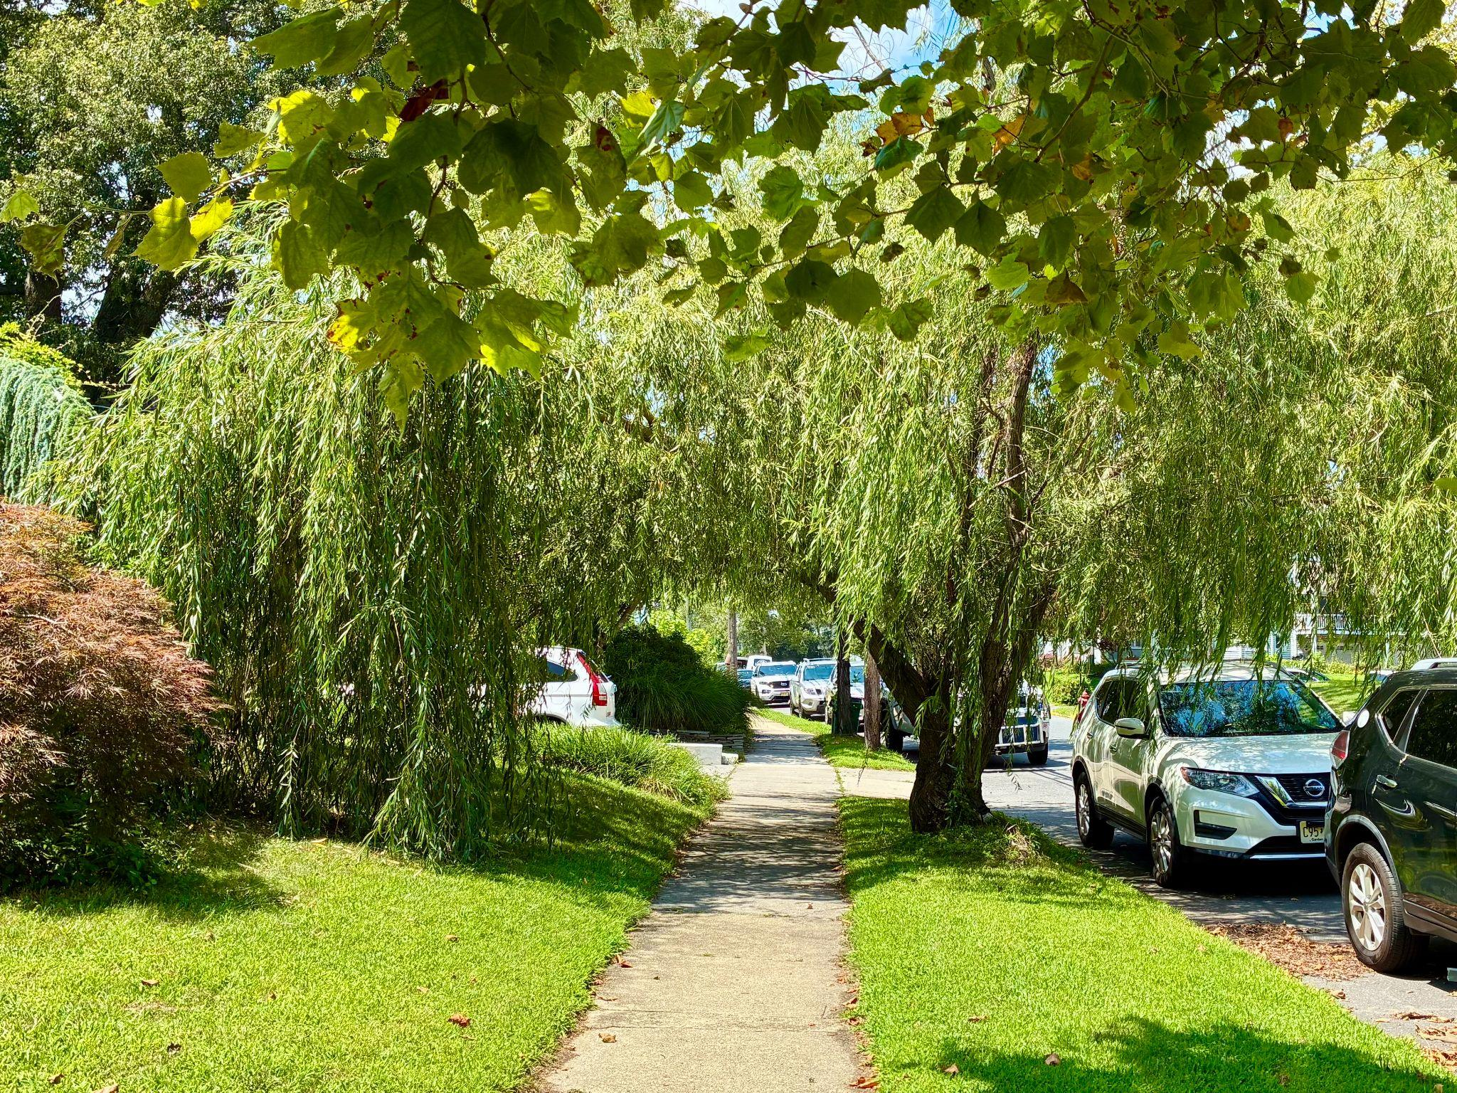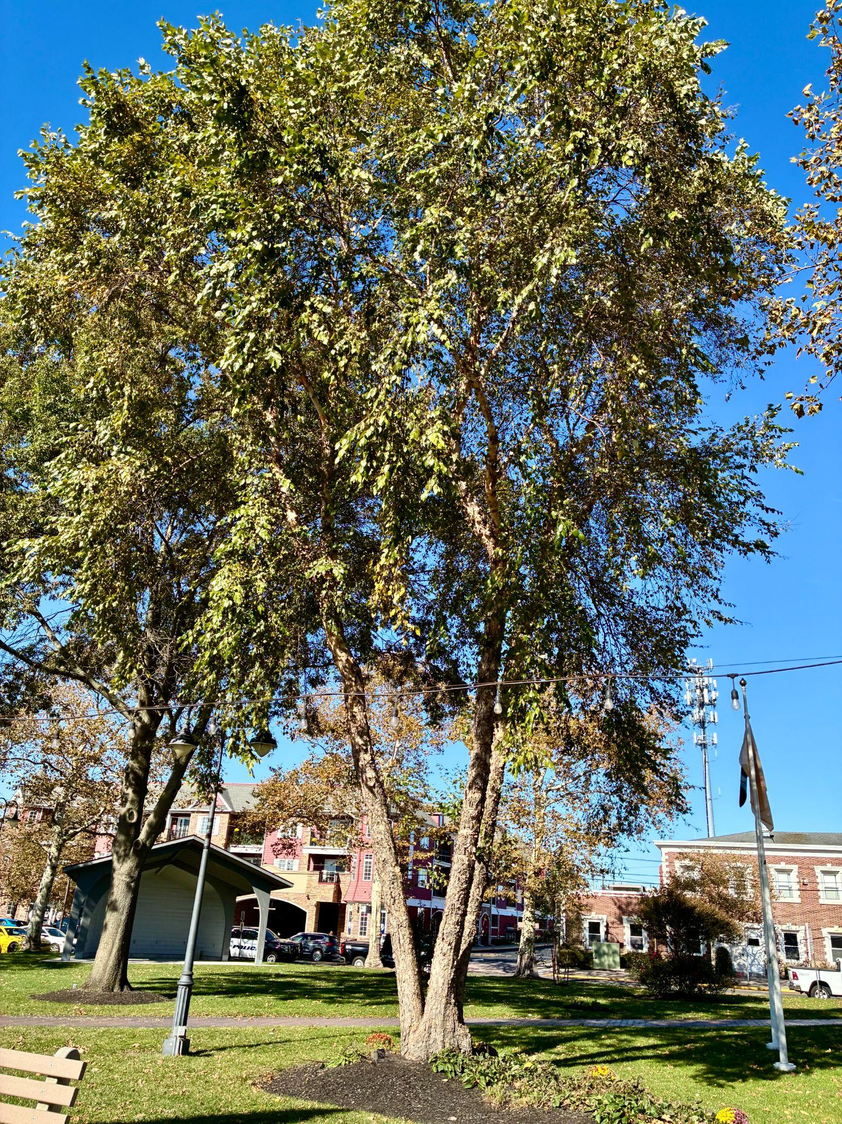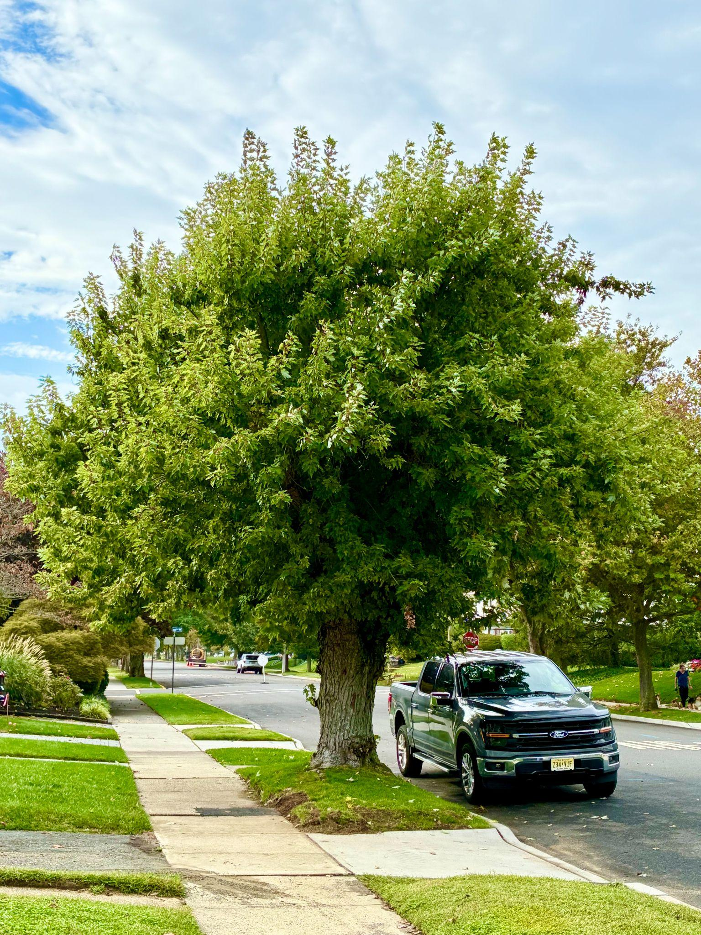

- The School Tree Tour continued at Bradley Beach Elementary School, with Jane DeNoble visiting classrooms at BBES and leading students around the campus to talk about the variety of trees.

- Bradley Beach was awarded the honor of Tree City, USA .

2025 Accomplishments:
The STC developed and implemented a new procedure for reviewing Tree Removal Applications. The new procedure involves a Commission member reaching out personally to each applicant to ensure that the application is properly filled out, and the Commission understands exactly what the resident is asking. The point of contact on the Commission can take photos if the tree is not easily seen on private property. We can also direct the resident to the resources on the STC webpage. Once this interview is over, a detailed explanation is sent to the other commission members before the next meeting. This new procedure gives the Commission the opportunity to connect with residents directly and guide them toward making replacement tree choices that are suitable for their location, as well as letting people know that we can do more than approve or deny their applications. So far, the program is a resounding success, not only in making connections and raising awareness of our presence, but also in making committee meetings more efficient.

The STC celebrated Arbor Day 2025 not with a tree, but with a bunch of NJ appropriate woody shrubs. The median on Second Avenue and Beach was planted with 16 more blueberry bushes, making the total 20 bushes, to create the Bradley Beach Blueberry Barrens. This project was funded by the STC and executed in collaboration with the Garden Club and the Eco Club of Bradley Beach Elementary School. The students and teachers met with the STC after school and planted the bushes. DPW got the holes started, and the students and teachers helped alongside the STC members to set the bushes into the ground, water them and feed them. Even Morty, the Reading Therapy dog of BBES, helped with some of the digging. Mayor Gubitosi, along with Councilwomen Jane DeNoble and Shana Greenblatt, joined the Arbor Day Celebration on Second Avenue as he read the Arbor Day Proclamation. The Bradley Beach Blueberry Barrens was dedicated to the BBES Graduating Class of 2025. Then we all rewarded ourselves for our strenuous efforts with a pizza party.
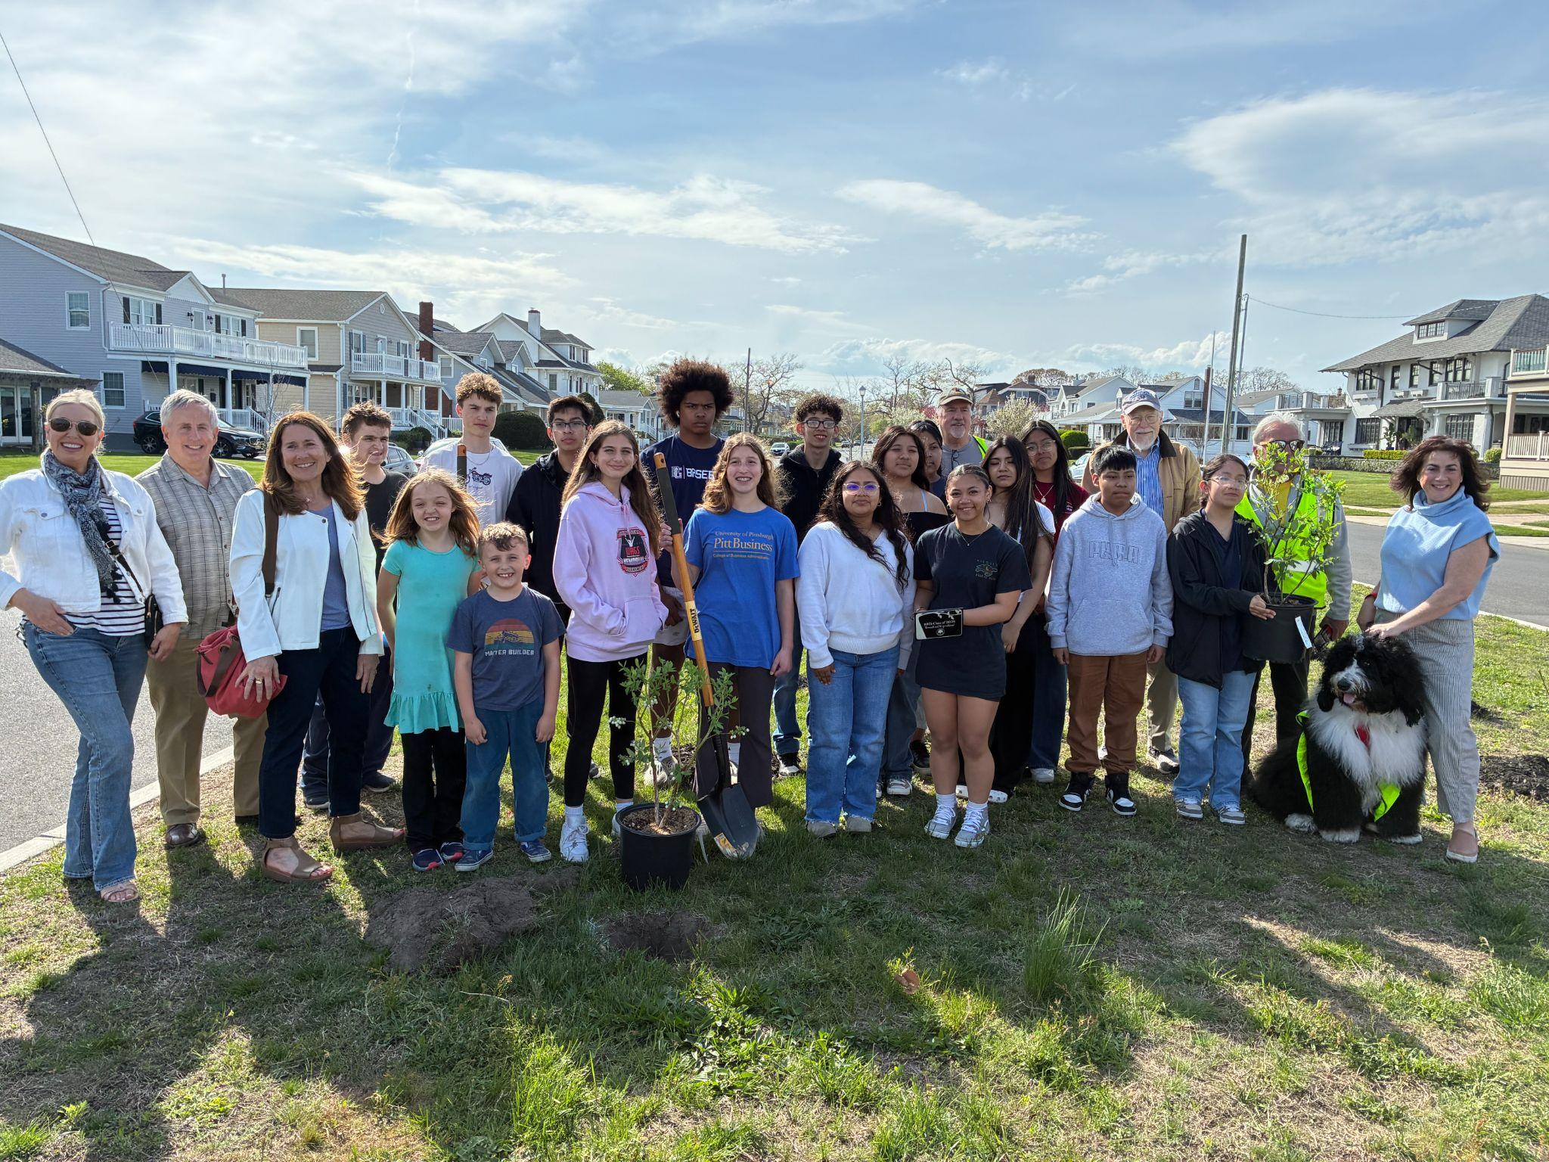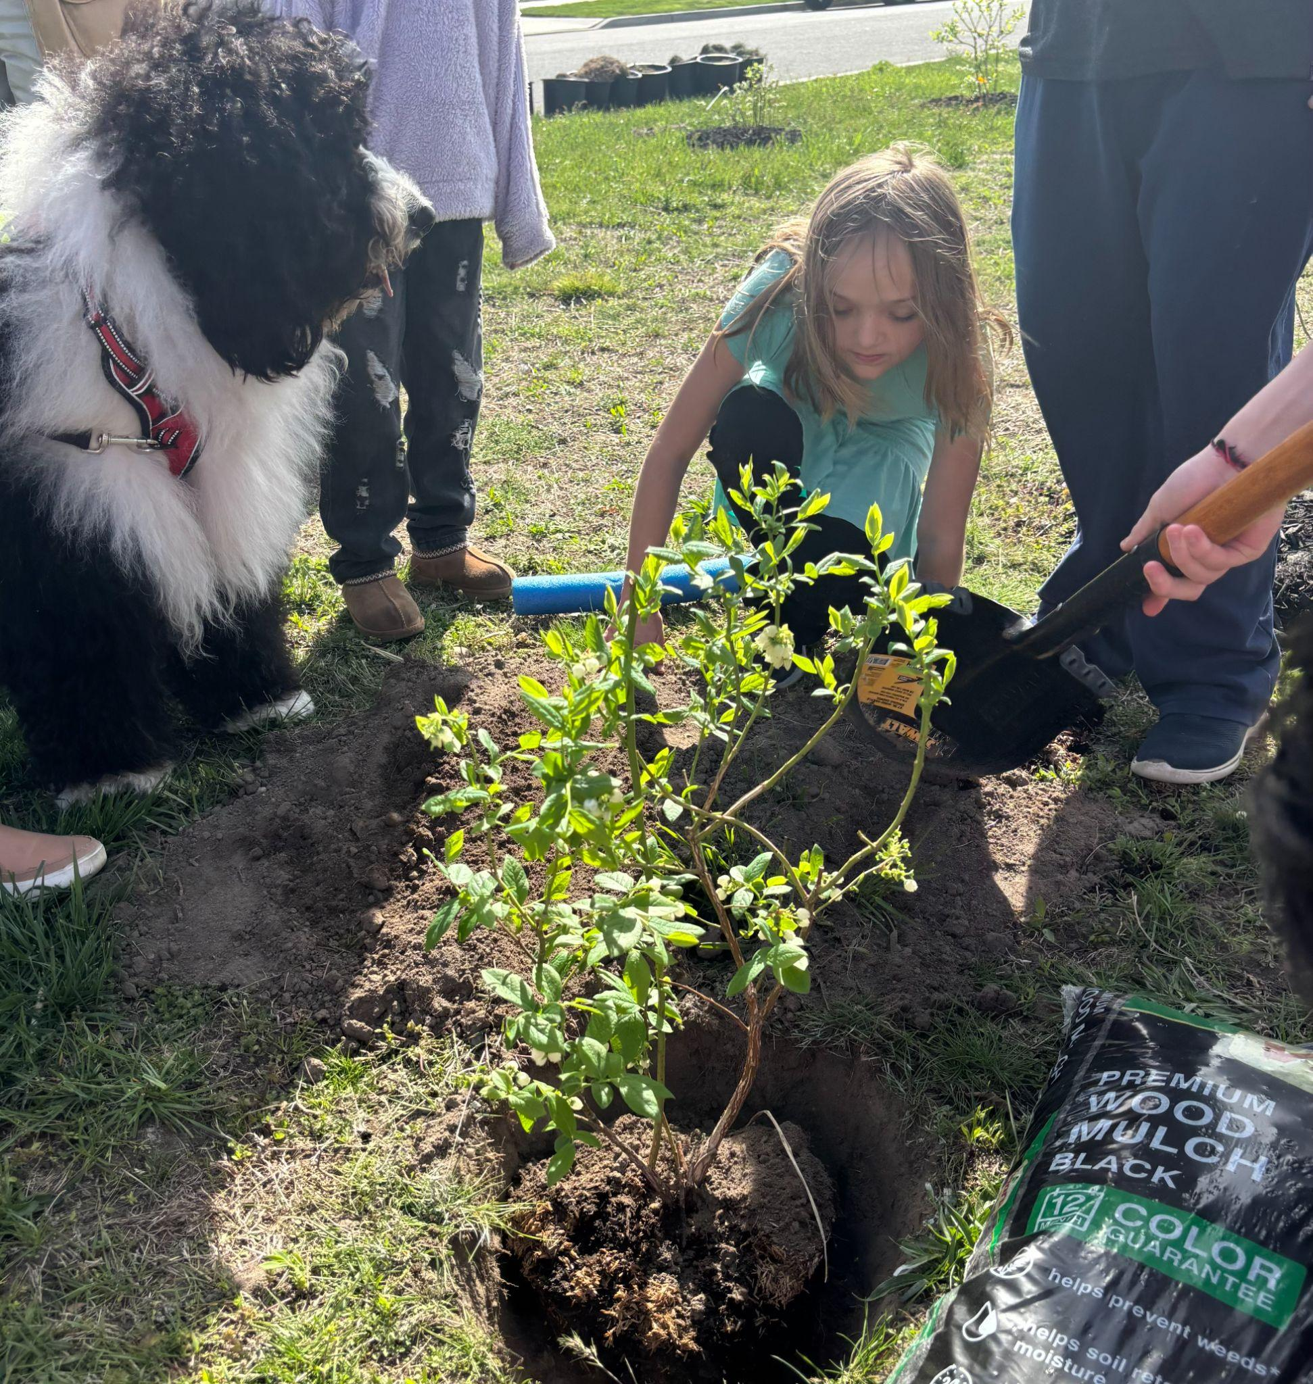

The STC spent many months in 2024 and 2025 working on revisions to the Shade Tree ordinances. These newly revised Ordinances were accepted and put into place in 2025, and will serve to help the STC review applications in a clearer, more efficient manner.

Jane DeNoble was back at BBES by popular demand to take students on a tour outside of their own school, pointing out the varied species of trees that can be found on the beautiful campus. She instructed the children about the different characteristics of many of the trees, on the value of planting native species, and the importance of trees in our ecosystem. Programs like this help BBES to maintain their Green Schools certification.

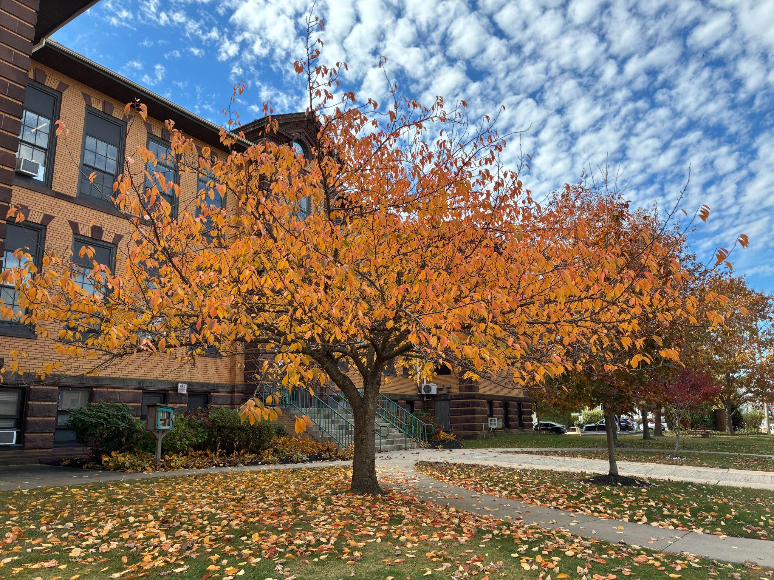

For the 15th year in a row, Bradley Beach was named a Tree City, USA. Nick Kosrych, STC Vice-Chair, is largely responsible for completing all of the work involved in receiving this recognition. Nick also completed the 5 year plan for which the STC was awarded a grant by the NJ Urban and Community Forestry Grant. This has been a 5 year long process, and the STC thanks Nick for his dedication and commitment to the process.

And finally, The Bradley Beach Shade Tree Commission was awarded a NJ Urban and Community Forestry Grant for $40,000 to plant trees in Bradley Beach. The NJDEP will provide trees, mulch, watering bags, and the labor to plant the trees. The STC canvassed the town to hand out Wishing Tree applications and now there is a tentative plan in place for the NJDEP to plant 79 trees on Borough property and planting strips around town. Whatever trees are not covered by the grant will be purchased and planted by the STC in the Spring of 2026. We are still accepting Honor Me and Wishing Tree applications for the Spring of 2026. https://thecoaster.net/2025/08/19/free-trees-available-in-bradley-beach/

